**Name: ________________________ Section ____ Activity No. 4**

**Windows Command Prompt**

The Windows Command Prompt which was reminiscent of the DOS or Disk Operating System before is one way of interacting with your Windows Operating System using text based commands instead of Graphical User Interface (GUI) which Windows of today is known for.

First you need to go to the command prompt and I will show you the long method and then short method.

**Long method:**

* Click on **Start** (Windows XP) or the **Start button** (Windows 7 or Vista)
* Click **All Programs**, followed by **Accessories**.
* Choose **Command Prompt** from the list of programs.

And you should have the screen like this one:

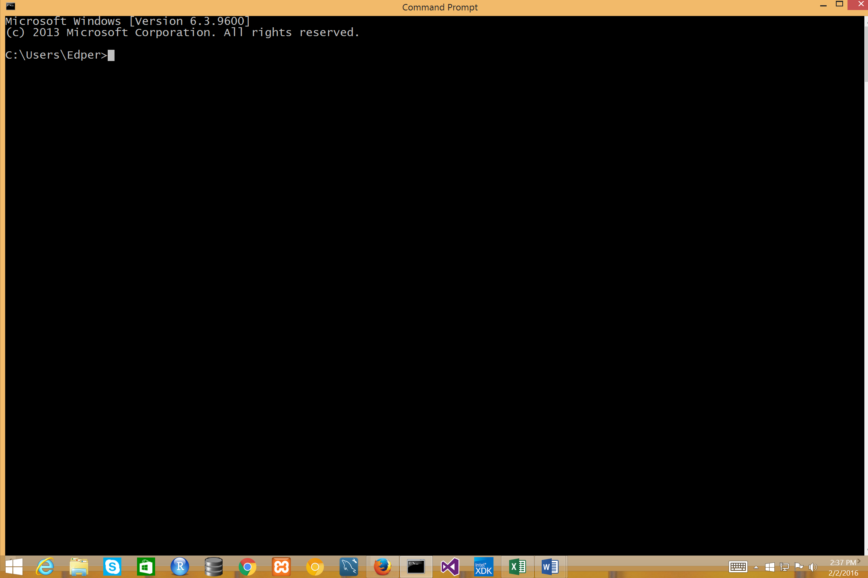

Now, for the **shortcut method** in terms of being faster:

* Press Windows button plus R or Win + R as shown below, to open the *Run* prompt:

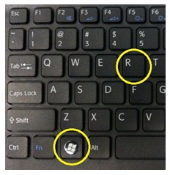

* Then type **cmd** and then press Enter key, as shown below.

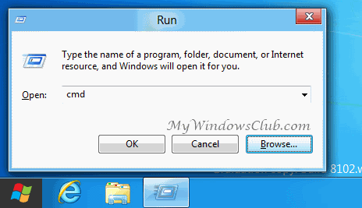

Now, you are on what is known as the **Command Prompt**. As the name implies it is prompting you to enter a command. So, let’s start.

**DIR command**

The DIR command allows you to list/show the directory (or folders) and files that is in your current directory. Type **dir** as shown in the example below in your command prompt and then press enter.

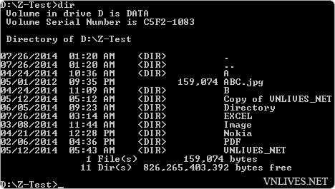

Looking at the output above the one that has the <DIR> label that means it is a directory or what is known as folders in Windows. For example EXCEL, Nokia, Image etc are all directories. Now, the one that has no <DIR> before them that means it is a file. For example above we see *ABC.jpg* which is actually a file and not a directory. And if you observe at the bottom part of the list you see the label *1 File(s)* and *11 Dir(s)* which means on the list you have one file and eleven directories. Also the date and time the file or folder is created is shown. And for file the number of bytes that file is. For example *ABC.jpg* has *159,074* bytes file size.

**Pit Stop No. 1 : Checking your understanding**

1. How many directories does your list have? <Answer here>
2. How many files? <answer here>
3. Name at least two directories. <answer here>
4. Name at least one file and its size. <answer here>

**USING WIDE DIRECTORY**

You can actually show the list of your files and directories (again folders) using a /w in your directory command. Type **dir /w** in your command prompt and press enter and see what happens. It should basically look like the one below in its format.

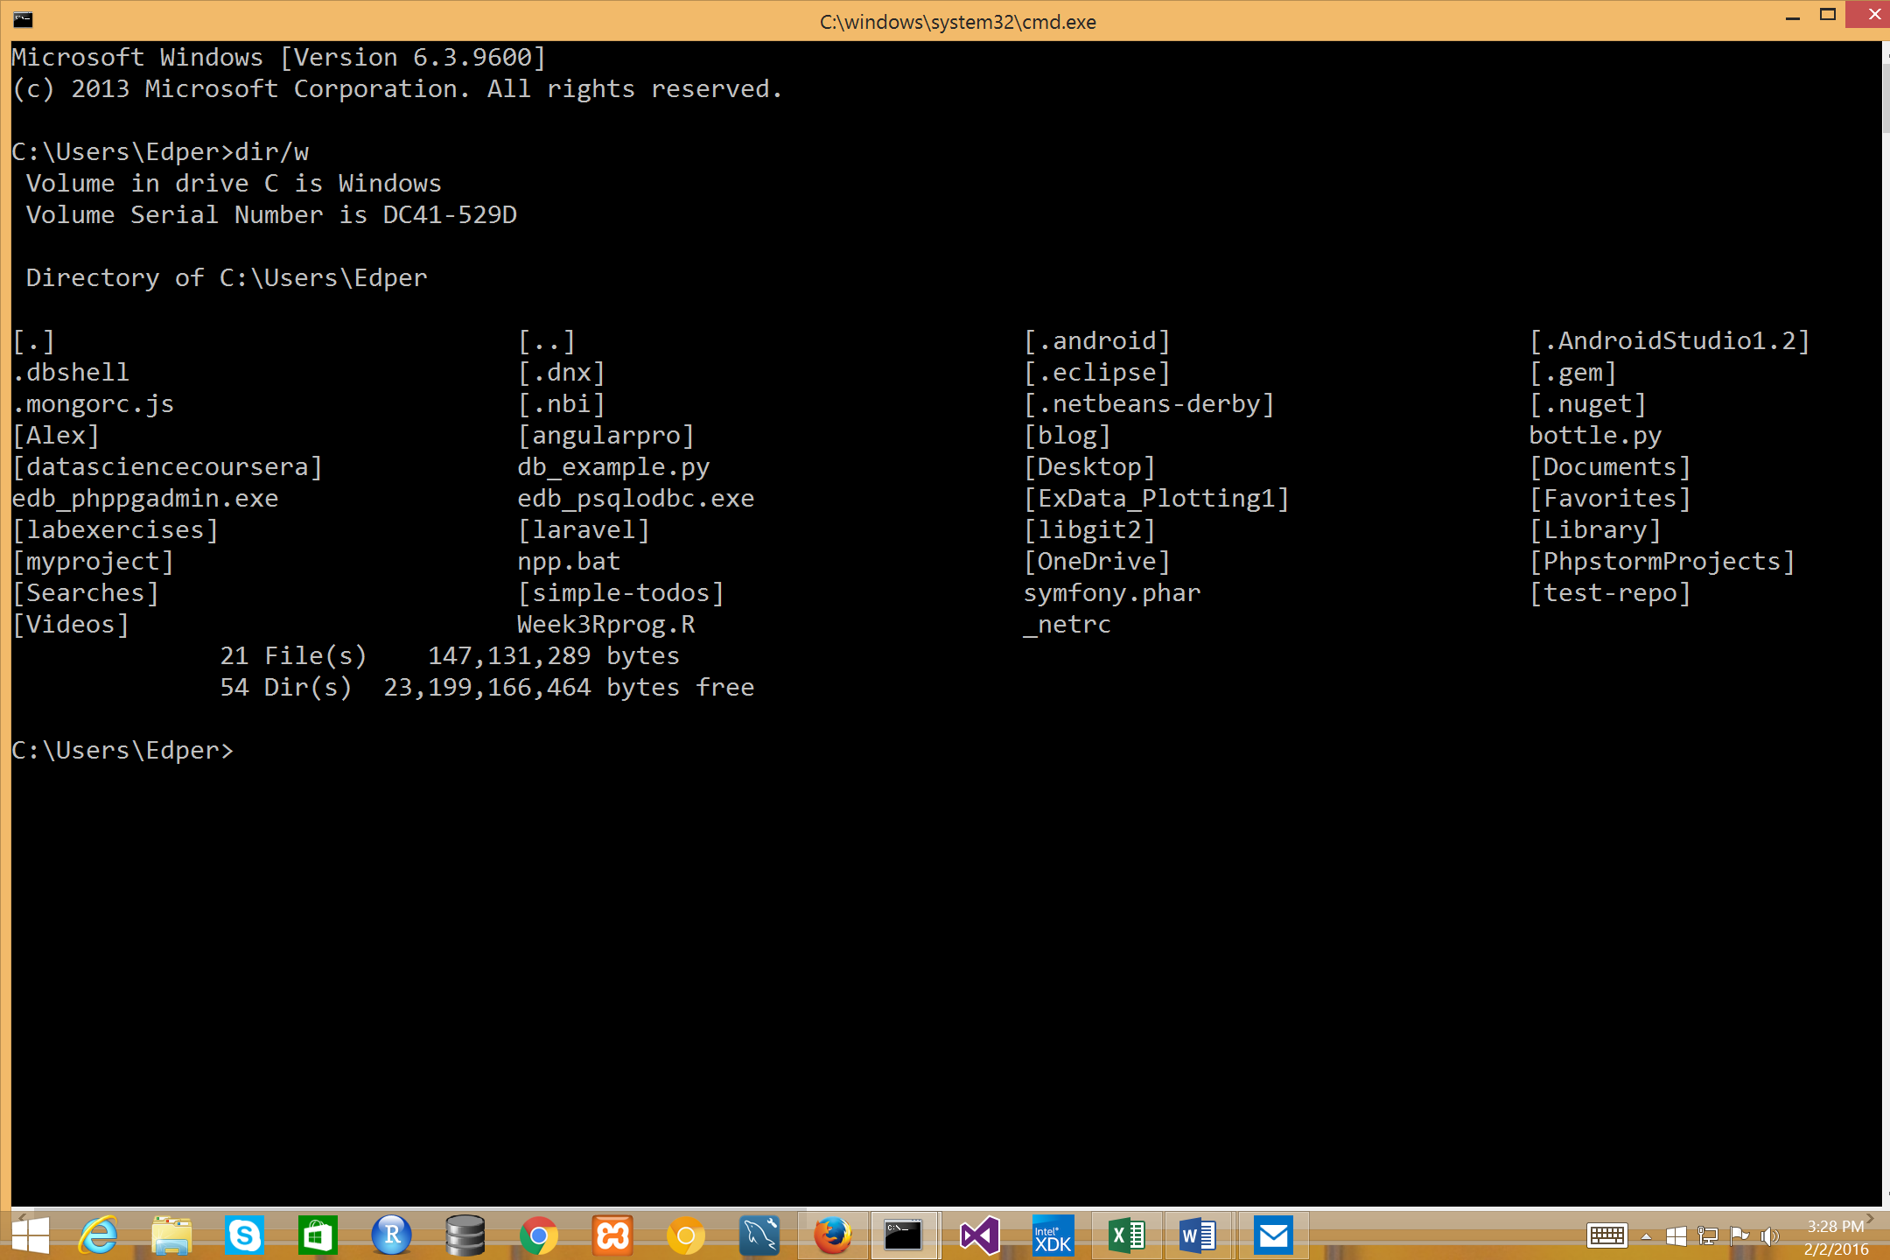

If you observe only file or directory names are shown but the date and time of its creation are not shown and as well as the file size (if you have a file in your directory).

**USING WILDCARDS**

Sometimes you need to manipulate or access files or directories (again folders) that are more than one. And working on it one by one would be very tedious. So, in relation to that you can work with multiple files using what is known as wildcards. Wildcards by the way are not only peculiar to command prompts but in many applications as well like in databases and programming languages. There are two type of wildcards, namely, the asterisk (*) and the question mark (?). The **asterisk** represents *zero, one or more* alphanumeric characters while the **question mark** represents any *single* alphanumeric character. To illustrate the usage of wildcards in command prompt let’s imagine that we have the following files.

*pix1.jpg*, *pix2.jpg*, *pix3.png*, *pix21.jpg*, *pixel.jpg*, *prices.xlsx*, *sky.jpg*, *sky.gif*, *shoes.gif*, *school.docx, tv8.gif, tv9.gif, tv10.gif* and *test.docx*

So, given the files above if I have to list all files that starts with letter **p** , it would look this:

[**Note**: Only the one in **bold** are the commands]

C:\Users\Edper>**dir p\***

Using the command above it would only list these files, namely, *pix1.jpg*, *pix2.jpg*, *pix3.png*, *pix21.jpg*, *pixel.jpg* and *prices.xlsx* which all starts with letter **p**.

**Pit Stop No. 2 : Checking your understanding**

1. What would be the command to list all files that starts with letter **s**? <Answer here>

Now, what if we want only to show filenames that starts with the word **pix**? Well, you can do that as well, as shown below.

C:\Users\Edper>**dir pix\***

Using the command above it would only list these files, namely, *pix1.jpg*, *pix2.jpg*, *pix3.png*, *pix21.jpg* and *pixel.jpg* which all starts with the word **pix**.

Let’s make it more interesting. We want to show files that starts with the word **pix** but only the one that has the file extension of **jpg**. The command then would be:

C:\Users\Edper>**dir pix*.jpg**

Using the command above it would only list these files, namely, *pix1.jpg*, *pix2.jpg*, *pix21.jpg* and *pixel.jpg* which all starts with the word **pix** and has the file extension jpg. Notice that *pix3.png* is not included because although it starts with the word **pix** but its file extension is **png**.

Using the * wildcard you can also show all files that has a certain file extension. Let’s say we want to show all files that has the extension of **jpg**, then it would the command would look like this:

C:\Users\Edper>**dir *.jpg**

Using the command above it would only list these files, namely, *pix1.jpg*, *pix2.jpg*, *pix21.jpg*, *pixel.jpg* and *sky.jpg* which all have the file extensions **jpg**.

**Pit Stop No. 3 : Checking your understanding**

1. Show all the files that starts with the word **sky**. <Answer here>
2. Show all the files that starts with the letter **s** but with file extension of **gif**. <Answer here>
3. Show all files that has the file extension of **gif**. <Answer here>

Now, we have learn so far the (*) wildcard which represents zero, one or many alphanumeric characters. Let’s look the other wildcard which is the (?) and that represents any zero or single character.

Suppose we want to show files that stars with the word **pix** and followed by any single character that has the file extension **jpg**. Then we would have the following:

C:\Users\Edper>**dir pix?.jpg**

Using the command above it would only list these files, namely, *pix1.jpg* and *pix2.jpg* but not *pix21.jpg* because it has two characters and not also *pix3.gif* because it has the extension of gif.

But if we want to include to characters as well then it would be like this:

C:\Users\Edper>**dir pix??.jpg**

This time it would now include *pix21.jpg* aside from *pix1.jpg*, *pix2.jpg*.

**Pit Stop No. 4 : Checking your understanding**

1. What would be the command to list all files that starts with the word **tv** and then followed by a single character? <Answer here>

Now, let’s make it real this time. Go back to your command prompt and do the following command first (we are going to learn on this command soon).

C:\Users\Edper>**cd\windows**

**Pit Stop No. 5 : Checking your understanding**

Now, using what you learn do the following.

1. List all files that starts with letter **w**. <List the files here> and <List here the command that you used>
2. List all files that starts with word **system**. <List the files here> and <List here the command that you used>
3. List all the files that has the file extension of **ini**. <List at least two files here> and <List here the command>
4. List all the files that starts with the letter **w** and has the file extension of **exe**. <List at least two files here> and <List here the command>

Now, there are files in Windows that are not shown right away. These are what is known as *hidden files*. Being hidden is one of the attributes of a file in windows (there are at least four but more on this in a moment). So, if you want to display or list the hidden files using **dir** command, you can do the following:

C:\windows>**dir /ah**

Now, the parameters (i.e. **/ah**) of the **dir** command above has meaning. First the **/** (front slash) indicate that what comes next is/are parameter(s) of a command. So, the letter **a** stands for *attribute* and letter **h** stands for *hidden*. Therefore, what you are trying to do here is that you want to display the files whose attributes are hidden.

**ATTRIB COMMAND**

Now, since we are talking about file attributes there are more than one attributes that can be associated with a file in Windows as I’ve mentioned earlier. And the following are the attributes:

**Attribute Meaning**

**H** Hidden files.

**A** Archive files which is the most common and the default attribute.

**R** Read-only files.

**S** System files which are files that are part of the Windows Operating System and

therefore not to play around with.

Now, using **attrib** command you can view (and more in a moment) the attribute of a file. Try to do the following in your command prompt.

C:\windows>**attrib**

As you can see it shows all the attributes of your files indicated by the four letters mentioned above as labels for its attribute.

You can also use **attrib** command to either set/make or clear/remove an attribute of a file. For example let’s say we have a file named *myfavorite.docx* and we want to hide this file. Then we can do the following:

C:\windows>**attrib +h myfavorite.docx**

The +h parameter above means this. The plus sign (+) means you set or make an attribute. And the letter h means hidden. Taken together it means then that you want to set the attribute of *myfavorite.docx* to a hidden file.

Now, what if you want to clear or remove the attribute. You can use then the minus (-) sign to do that as shown below.

C:\windows>**attrib -h myfavorite.docx**

You can also set by the way multiple attributes of a Windows as shown below, which set the attributes to both hidden and read-only.

C:\windows>**attrib +h +r myfavorite.docx**

Make sure by the way that there are spaces between +h and +r.

Now, let’s try what we learn so far. Exit from the command prompt by typing the following command. By the way this is not way to do this but for the meantime since your knowledge is still limited on this, let’s leave it this way.

C:\windows>**exit**

Now, try to open the command prompt again (this is also a good way of learning how to do it yourself now). And on the command prompt try to list all files using the **dir** command. Then identify one file that you would like to play around with the *attrib* command.

**Pit Stop No. 6 : Checking your understanding**

1. Set the attribute of your file of your choice to read-only. <answer here>
2. Now, clear the read-only attribute. <answer here>

**WORKING WITH DIRECTORIES**

So, far you can list files and directories (or folders). But what if you want to move inside a directory/folder? Or better yet create your own directory? We can do this with two important commands, namely, **cd** and **md**.

**CD COMMAND**

The cd command stands for *change directory*, that is, you can move to another directory/folder using cd command. Now, let’s try this. Since you have already listed the files from the previous commands. Try to check one of the directory or folder listed. Let’s say there is a folder/directory named desktop. Then you want to move inside that folder/directory. So, you can do the following command.

C:\Users\Edper>**cd desktop**

After execute the above command you can observe that you command prompt changed to almost something like this.

C:\Users\Edper\Desktop>

That’s because you are now inside the folder/directory named *desktop*. The cd <directory name> command like *cd desktop* by the way uses what is known as *relative path*. *Relative path* means you can only move down to a directory that is within your current directory. For example if there is a directory/folder somewhere that is not under c:\users\edper then I could not use this type of command. I will instead use an *absolute path* method which we will learn in few moments.

Now, what if you want to go back one directory/folder up, that is, the folder/directory where you came from. You can do this with the special command like this.

C:\Users\Edper\Desktop>**cd..**

And the result is you are going one directory up or back to where you are before, as shown below.

C:\Users\Edper>

Now, what if you want to go back two or more directory/folder up? You can go back to the *root directory* with the following command.

C:\Users\Edper>**cd\**

And the result is you are going back to the root directory as shown below.

C:\>

The **cd\** command by the way uses *absolute path* meaning you can anywhere you want to go if you use the **\** in your cd command. This is in contrast of what I mentioned earlier, that is, using cd <directory name> or cd with a space instead of a backslash (\) uses *relative path* method.

So, as I’ve also mentioned earlier you can go to any folder/directory anywhere using *cd* command. For example you can do the following command.

C:\>**cd\windows\system**

Now, are now in the following directory/folder.

C:\windows\system>

The absolute path method allows you to move directly to *c:\windows\system* directory/folder without having to issue multiple cd commands.

**Pit Stop No. 7 : Checking your understanding**

1. Using absolute path method move to **c:\users\whatever_username_here** (for Windows 7 or 8) or to **c:\document and settings\whatever_username_here** (for Windows XP). <answer here>
2. Using relative path method move down to another directory that is in the current directory. <answer here>
3. Using cd command move up from your current directory. <answer here>

**MD COMMAND**

So, far you have been moving or navigating among directories through the use of cd command. Now, it’s the time create a directory or a folder. To do that you need to use the MD command. Let’s say you want to create a folder or directory according to your last name. So, if I am the one who is going to make it would look like this:

C:\Users\Edper>**md castro**

You have now created a directory according to your last name (in my case it’s castro). Now, let’s say if shows. Try to execute the following command.

C:\Users\Edper>**dir /ad**

The command above allows you to list only items whose attribute is a directory thus */ad*. Did you see your last name?

**MOVING TO ANOTHER DRIVE**

So, far you have been moving or navigating among directories. But what if you want to change drive. Let’s say you want to move to another drive like your USB thumb drive? You can do this by simply typing letter of the drive plus a colon ‘:’. Try to insert first a flash drive in the USB port of your computer. And let’s say we’re done with that and that your flash drive is in drive E. So, you can execute the following command.

C:\Users\Edper>**e:**

And if you want to go back to you drive c, you can then do this.

e:\>**c:**

**COPYING FILES**

You can copy files from to another file or from one directory to another directory or from one drive to another drive. The syntax for copying files is the following:

**Copy <source file(s)> <destination>**

For example let’s say you have a file in your folder named *test.txt* and you want to copy it to *test2.txt*. Then it would look like this.

C:\Users\Edper>**copy test.txt test2.txt**

Now, if you want to copy the test.txt to another folder let’s say to desktop, it would look like this.

C:\Users\Edper>**copy test.txt c:\Users\Edper\Desktop\**

Or it desktop is relative or close to your current directory then you can do this.

C:\Users\Edper>**copy test.txt Desktop**

Now, if you want to copy a file to a drive let’s say drive e, then it would look like this.

C:\Users\Edper>**copy test.txt e:**

You can also use wildcard in copy command. Let’s say you want to copy all the jpg files into your flash drive, in e. You can do this then.

C:\Users\Edper>**copy *.jpg e:**

**Pit Stop No. 8 : Checking your understanding**

1. Copy any file that you want to another filename. <answer here>
2. Copy any file that you want to the directory you just created that bears your last name. <answer here>
3. Copy that file to your flash drive. <answer here>
4. Copy all files that starts with letter **f** to your flash drive. <answer here>